# Solution Report

**Team:** Mor, Samson, Alexandra, Irit

(**note**: while all listed page limits are recommendations, and not absolute restrictions, we do ask that you adhere to them as best you can)

## Part 1: Architecture and use

**Architecture**

Please provide a diagram illustrating the system architecture and briefly explain its components.

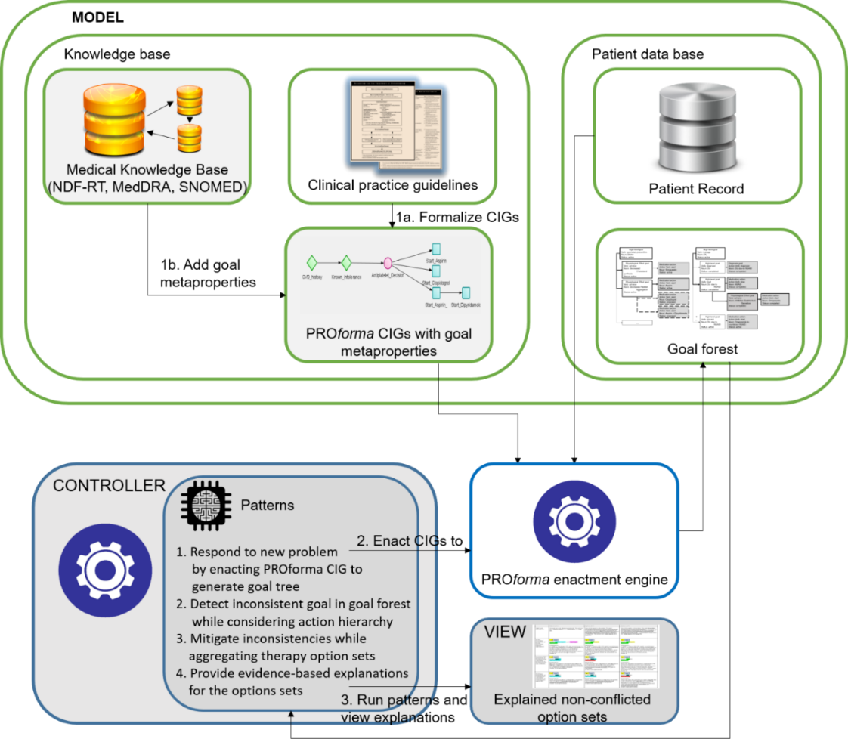

Figure 1. GoCom’s Architecture

As shown in Figure 1, we utilize the Model–view–controller (MVC) software architecture. (1) the View is the implementation of the user interface; (2) The Controller is the algorithm that manages the functionality of the Model and the View and in addition implements all of the patterns and functionalities needed for detecting and mitigating inconsistencies among CIGs recommendation; (3) The Model is the component that implements the medical knowledge (CIG knowledge base and the NDF-RT) as well as the patients’ data. All of the parts in the model, including the knowledge base and patient data base are automatically accessed by the Controller component. The Controller implements a novel algorithm that creates the goal trees based on results of the PROforma enactment engine that is running the CIGs from the KB. The Goal Trees are not part of PROforma or its tools.

**CIG representation**

Please explain the formalism used to represent CPGs.

**(i) CIG**

* Clinical Practice Guidelines (CPGs) modeled in PROforma to form Computer Interpretable Guidelines (CIGs).
* Since PROforma doesn’t directly support goals, we add annotations to PROforma tasks (Plan, Action).
* We modeled different types of goals that are inspired by a paper of John Fox[1] where he models an ontology of goals. There are 3 types of goals that all have sub-types:
  + State-achievement goal – source: Fox’s ontology of goals
    - Treatment goal – source: high-level medical practice
    - Prevention goal – source: high-level medical practice
    - Physiological effect goal – source: the NDF-RT Physiological Effect (PE) attribute of a drug.
  + Action-enactment goal – source: Fox’s ontology of goals
  + Knowledge goal – source: Fox’s ontology of goals
    - Diagnosis goal– source: high-level medical practice
* Plans and Actions are means to achieve goals. Plans are hierarchical. They can contain other tasks inside as well as other plans. This allows us to create a hierarchical goal tree based on the goals associated with the plans and actions. While plans can be associated with different types of goals, Actions are usually associated with Action-enactment or Diagnosis goals.
* All goals in a PROforma guideline have a description field, where the text from the guideline document that describes the recommendation relevant to the goal is stored. In addition, all goals have a PROforma metaproperty, which we refer to as the “addresses metaproperty” that reflects the "addresses" property of the “Goal” class in the FHIR standard. In this metaproperty, we added json-formatted specification that contains information about the goal that is needed for the Controller to reason over the goals later. The “addresses” specification contains two attributes that were also inspired by Fox’s goal ontology:
  + Verb – to indicate what the goal is meant to do (manage, treat, prevent, start, stop, achieve, avoid, decreased, increased, inhibition, stimulation, suppression, negative, positive, depolarization, repolarization, vasoconstriction, vasodilation).
    - Noun phrase – can be simple or complex. A simple noun phrase contains the object of the goal (e.g., “Omeprazole”) specified with its ontology code, name and vocabulary as well as the type (medication, disease, physiological effect). For physiological effects, the noun phrase also contains the modifier of the physiological effect (e.g., “Decreased” in “Decreased Platelet Aggregation”) and the clinical attribute (e.g., “Platelet Aggregation” in “Decreased Platelet Aggregation”).

A complex noun phrase is a composite object that connects two noun phrases via two types of relationships:

* + - Due to – indicates that a disease has occurred due to a treatment that was given to the patient
    - To counteract – indicates that a specific medication was given to the patient in order to counteract the effects of another medication.

The complex noun phrase object can contain many levels of hierarchy as every object in the complex noun phrase can be a complex noun phrase in itself.

* See Part 3 Case 1 for examples of PROforma encoding of guidelines and the added addresses metaproperty.

**(ii) Goal Trees**

* For each CIG that is applied to the multimorbidity patient's data, a goal tree is generated. The tree nodes contain the patient’s goal-recommendations from the CIG. The structure of each node is defined according to a FHIR Goal class, with added attributes – “children”, “parent id” and “proposed action” to facilitate functionalities needed in the goal tree. The properties of a Goal node include:
  + Resource type – “Goal” – as per the FHIR standard
  + Id – an ID assigned by the Controller after it retrieves the goals from PROforma
  + Parent id – the ID of the parent. Also assigned after retrieval from PROforma
  + Description – contains text from the guideline that is manually entered by the modeler and describes the goal; or, if the reasoning used to generate the explanation depends on the intelligence of the controller, then the description is an auto-generated description, generated by the Controller. The intelligence of the Controller includes generic behavioral patterns that are not hard-coded. For example, to conclude that there is an Adverse Event, or to suggest stopping a drug that caused an adverse effect.
  + Addresses – contains the verb and noun-phrase of the goal
  + “lifecycleStatus”. The new goal tree will contain mostly goals that are “proposed” while existing interventions will be reflected in the status “active” (or “on-hold” if they are suspended). The possible life cycle statuses are: proposed | planned | accepted | active | on-hold | completed | cancelled | entered-in-error | rejected.
  + Proposed action – contains the future status of the goal as proposed by the Controller during mitigation. In case a goal is to be replaced, it will also contain the replacement goal object of the current goal.
  + Children – contains the goals’ children (if there are any)
* For illustrative purposes, a schematic representation of the Goal Tree for the secondary prevention of DU due to NSAID is shown in Figure 2. The corresponding json is shown in Figure 3. (In reports of case studies, only the schematic representation of the goal forests will be used.) In this example, the root node is a high-level prevention goal involving a complex noun phrase, the middle node is a physiological effect goal, and the leaf node is an action-enactment goal starting a drug to counter the effect of another drug.

**2.4.1 Secondary prevention of Duodenal Ulcer due to NSAID; active**

**2.4.1.1 Inhibition Gastric Acid Secretion; active**

**2.4.1.1.1 start Omeprazole to_counteract Nonsteroidal Anti-inflammatory Drug; active**

Figure 2. schematic representation of the Goal Tree of DU

{

"resourceType": "Goal",

"id": "**2.4.1**",

"parent_id":"2.4",

"description": {

"name":"**Secondary Prevention of DU due to NSAID**",

"text": "Secondary Prevention of DU due to NSAID",

"grade":"auto-generated"

},

"lifecycleStatus":"active",

"subject": {

"reference": "Patient/130",

"display": "Linda Williams"

},

"addresses": [{"verb":"**prevent**",

"comment":"none",

"noun_phrase":{

"type":"problem",

"first_noun":{

"type":"problem",

"code":"N0000001008",

"name":"**Duodenal ulcer**",

"vocabulary":"NDFRT"

},

"second_noun":{

"type":"medication",

"code":"N0000175722",

"name":"**Nonsteroidal Anti-inflammatory Drug**",

"vocabulary":"NDFRT"

},

"connector_term":"**due_to**"

}

}],

"children":[{

"resourceType": "Goal",

"id": "**2.4.1.1**",

"parent_id":"2.4.1",

"description": {

"name":"**Inhibition_Gastric_Acid_Secretion**",

"text": "Inhibition_Gastric_Acid_Secretion",

"grade":"auto-generated"

},

"lifecycleStatus":"active",

"subject": {

"reference": "Patient/130",

"display": "Linda Williams"

},

"addresses": [{"verb":"achieve",

"comment":"none",

"noun_phrase":{

"type":"PE",

"modifier":"**Inhibition**",

"clinical_attribute":"**gastric acid secretion**",

"code":"N0000009724",

"name":"Inhibition Gastric Acid Secretion",

"vocabulary":"NDFRT"

}

}],

"children":[{

"resourceType": "Goal",

"id": "**2.4.1.1.1**",

"parent_id":"2.4.1.1",

"description": {

"name":"**Start PPI (Omeprazole)**",

"text": " **When DU develops and aspirin is maintained, PPI should be**

**added to prevent ulcer bleeding. Aspirin should be resumed as soon as possible after bleeding ceases in most patients: ideally within 1-3 days and certainly within 7 days. Long-term daily PPI therapy should also be provided.**",

"grade":"auto-generated"

},

"lifecycleStatus":"active",

"subject": {

"reference": "Patient/130",

"display": "Linda Williams"

},

"addresses":[{"verb":"**start**",

"comment":"long-term",

"noun_phrase":{

"type":"medication",

"first_noun":{ "type":"medication", "code":"N0000147569", "name":"**Omeprazole**", "vocabulary":"NDFRT" },

"second_noun":{ "type":"medication", "code":"N0000175722", "name":"**Nonsteroidal Anti-inflammatory**

Drug", "vocabulary":"NDFRT" },

"connector_term":"**to_counteract**"

}

}],

"children":[]

}]

}]

},

Figure 3. json of the Goal Tree of DU

**Domain knowledge representation**

If additional domain knowledge is required, please explain how it is represented. Indicate whether standards (e.g., SNOMED-CT, FHIR, standard domain ontologies) are being utilized.

External medical knowledge sources: the NDF-RT

* We are using general medical knowledge from the NDF-RT:
  + The diseases that may be treated or prevented by each drug

For example, in Figure 2, Goal 2.4.1 Prevent Duodenal Ulcer, which is satisfied by Goal 2.4.1.1 (see below)

* + The Physiological Effects (PE) of drugs.

For example, in Figure 2, the Goal 2.4.1.1 PE of inhibition of gastric acid secretion (NDF-RT) is satisfied by 2.4.1.1.1 Omeprazole (a PPI)

* + The relational representation of the NDF-RT provided by Athena OHDSI for determining drug subsumption hierarchies that can be found in the “concept_relationship” table (e.g., Aspirin is-a NSAID).

**Mode of use**

Please explain the intended mode of use of the system: who are the intended end-users, when is the system to be used: during patient encounter, real-time vs. simulation, etc.

* 1. User adding a new problem (which triggers the CDS)
  2. System providing explanations to the user.
  3. User selecting one of the recommended option sets. This results in the patient’s EHR being updated

**Strengths of the approach**

Does the approach have very good support for particular features? Which? Please justify. What is the singular point of strength of your approach?

1. Deployable system (so not just a method) designed to be a part of an ecosystem of informatics resources. Therefore it relies on established formalisms, data standards, standard terminologies and has facilities to interact with relevant external repositories.
2. In general, all of the features are supported except for A10 and A16 regarding monitoring drug effects and optimization
3. The point of strength of our formalism is the goal-oriented approach and its combination with a generic, automatic standardized methodology that also deals with related, cascading and concurrent interactions. In the case that was demonstrated, the interaction between “stop PPI” and “start Omeprazole” has created a cascade effect that affected the treatment for a third guideline (CVD) through a dependency “to_counteract” relationship. The goal-oriented approach allows us to produce an array of possible treatment options for the user, as well as explanations that clarify the reasons for the recommendation and the exact actions that need to be taken in each particular option. This allows more flexibility for the patient and a clear, concise picture of the patient’s situation for the physician user.
4. The approach is generic
   1. The CIG is represented in terms of PROforma goal-plans that are hierarchically nested, ending in a decision among low-level actions that fulfill the goals. A pharmacological treatment plan that includes a drug-prescribing decision is annotated with a Physiological_Effect goal from NDF-RT which could allow searching NDF-RT for other potential medications with the same effect, which may not be mentioned in the guideline. However, this option needs to be used with caution and is meant to support guideline authors and not physicians treating patients
   2. CIGs are not combined ahead of time manually, but remain independently modeled. The interactions are detected by the controller and the reasoning that is applied to the patient data is reflected in patient-specific goal trees. This could allow using a library of many CIGs and apply it to patients that have different combinations of morbidities.
   3. The algorithm uses an external knowledge source through API calls to detect drugs that are related and might cause possible interactions. "NSAID Subsumes Aspirin” is retrieved by searching the “concept_relationship” table of the NDF-RT provided by Athena OHDSI. The connection to the knowledge source through an API and not through a manually made representation is an additional generic aspect of the system.
   4. The option-sets and their explanations are generated generically. Depending on the number of interactions and dependencies that are found in the original goal-forest, there may be any number of option-sets generated.
5. Automated detection of interactions of two kinds
6. start Drug1 and stop Drug2 can be identified as conflicting even if they are from different CIGs and if Drug1 and Drug2 are not the same term but one is a drug group that subsumes the low-level drug (e.g., start Aspirin and stop NSAID).
7. The algorithm can detect pairs of opposing physiological effect goals, such as increasing vs. decreasing state (e.g., decreased platelet aggregation vs. increased platelet aggregation).
8. The approach utilizes standards: the patient’s EHR is implemented according to the HL7 FHIR standard. The coding system that is used is the NDF-RT terminology (see example – “start Omeprazole” goal addresses object in section 2a).

Part 2: Features

Section A outlines a set of features that relate to possible interactions among advice offered by CPGs. Section B lists a set of features that relate to possible mitigation strategies for these interactions.

Section C lists other possible features. We include a brief example to illustrate each feature.

For each of the features, please indicate whether it is supported, and, if so, briefly explain how.

We denote a goal in the goal tree for managing a disease using the notation [Disease, Goal]. The explanations below refer in yellow to algorithms published in [1] depicted in figures 8-10,12 in that paper.

REFERENCES

1. Alexandra Kogan, Mor Peleg, Samson W Tu, Raviv Allon, Natanel Khaitov, Irit Hochberg. Towards a goal-oriented methodology for clinical-guideline-based treatment recommendations for patients with multimorbidity: GoCom and its preliminary evaluation. Journal of Biomedical Informatics, October 6, 2020. <https://authors.elsevier.com/a/1c0Bq_YrQyH2A7>

### Section A. Interactions among CPGs’ advice

**A1**: Drug from a CPG has an effect on a comorbid condition

*For example, low-dose Aspirin (Cardiovascular Disease CPG) affects Duodenal Ulcer (comorbid condition).*

*Implemented (Y/N)*: Y

*Brief description*: When GoCom recognizes an inconsistency, and the inconsistency stems from a recommendation in one of the guidelines to stop a drug, the system concludes that the drug is a source of a potential or existing ADE. (e.g., Osteoporosis due-to PPI and DU due-to aspirin are represented in the goal trees – see Figure 6: 2.4.1 and 3.2.1, in step 2 in Kogan et al. [1] Figure 8 (High-level Pattern) and steps 17, 18 in Kogan et al. [1] Figure 9 (Pattern B)).

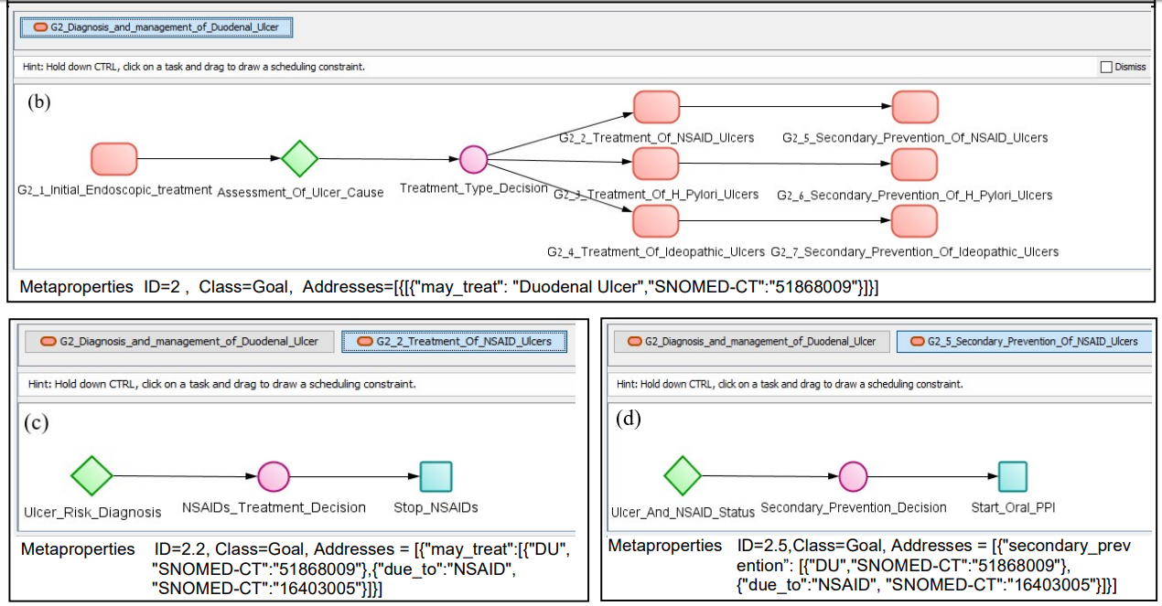

Note due-to in part (c) above and in part (b) of the goal tree below

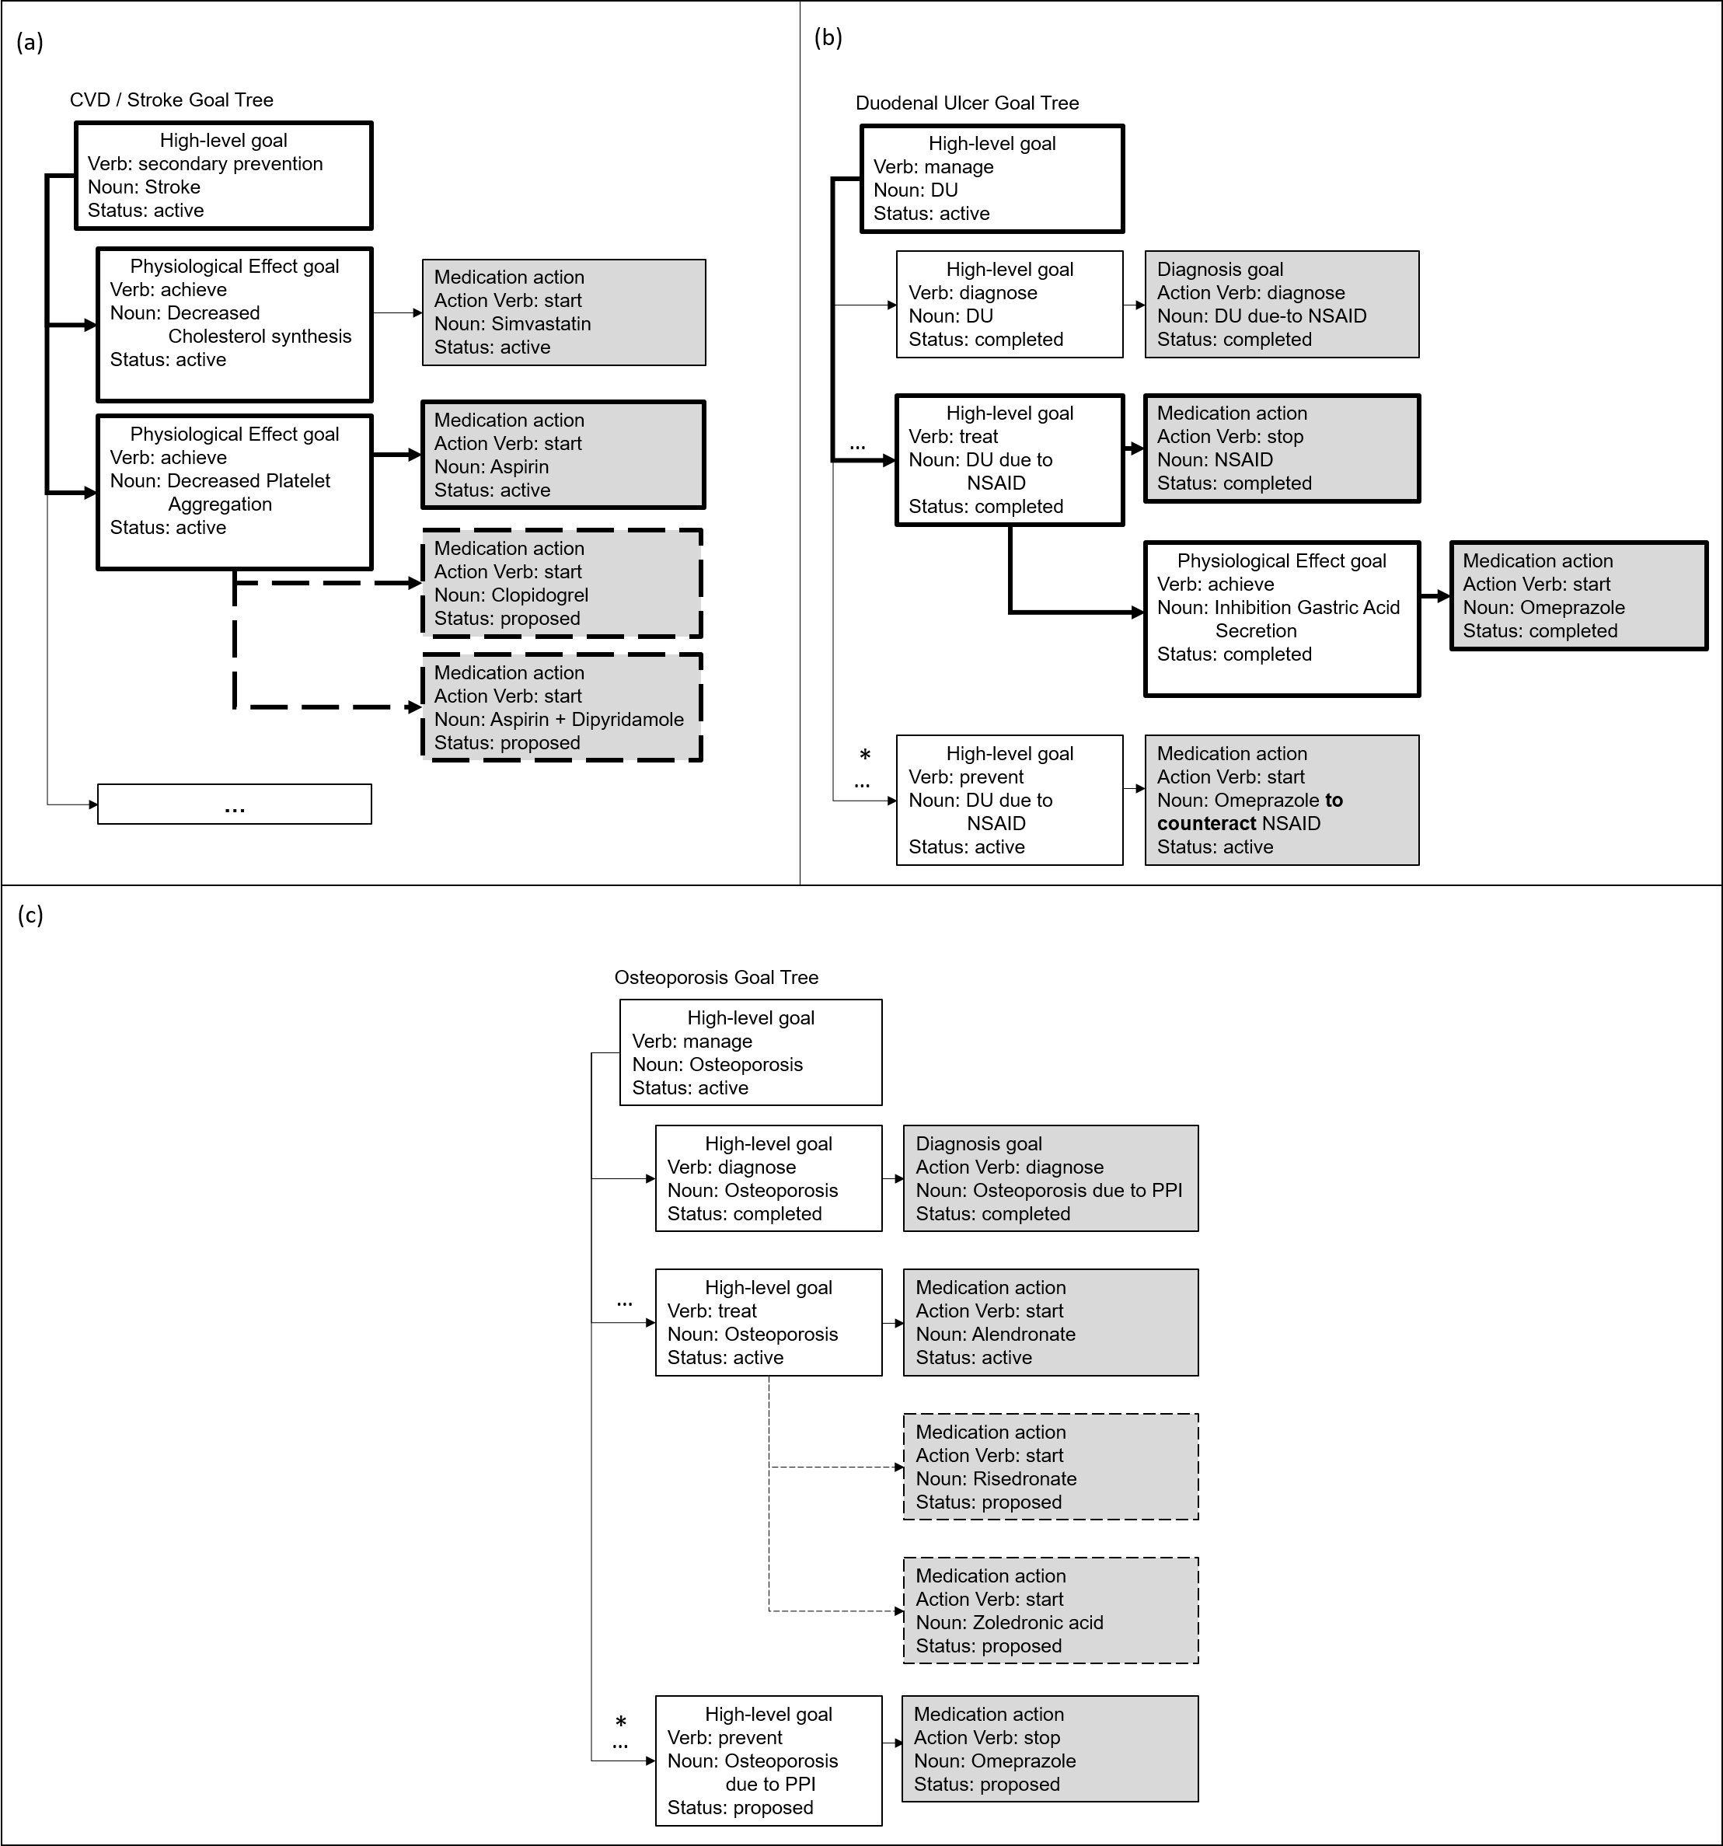

**A2**: Two or more drugs from different CPGs interact

*For example, antibiotics such as Trimethoprim/Sulfamethoxazole impact the anticoagulant effect of Warfarin.*

*Implemented (Y/N)*: Y

*Brief description*: these interactions may be detected in our Goal Trees only in cases where the drugs have opposing Physiological-Effect Goals (one has increased_state and the other decreased_state of the same state). For example, the drug TMP has_PE increased coagulation; Warfarin has_PE decreased coagulation (Case 3). GoCom’s inconsistency checking (steps 17, 18 in Kogan et al. [1] Figure 9 (Pattern B)) would detect inconsistent increase vs. decrease goal verbs and the same coagulation noun phrase).

**A3**: Clinical goals from different CPGs conflict

*For example, the goal of preventing thrombosis conflicts with the goal of preventing bleeding during surgery.*

*Implemented (Y/N)*: Y

*Brief description*: **to be completed (Case 4)**

**A4**: Conflicting actions (e.g., drugs, procedures) from different CPGs

*For example, one CPG recommends administration of Clopidogrel (Transient Ischemic Attack CPG) while another recommends suspending Clopidogrel (Coronary Artery Bypass Grafting CPG).*

*Implemented (Y/N)*: Y

*Brief description*: The inconsistency in [Osteoporosis. Stop PPI] vs. [DU, Start Omeprazole] is detected in steps 17, 18 in Kogan et al. [1] Figure 9 (Pattern B)) when we have start vs. stop and the noun phrases are either the same or one is a drug-group and the other is a specific drug belonging to the drug group (is-a hierarchy).

**A5**: Duplicate or redundant advice from different CPGs

*For example, Calcium Channel Blockers are recommended in Hypertension and Cardiovascular Disease CPGs.*

*Implemented (Y/N)*: Y

*Brief description*: **to be completed (Case 4)**

**A6**: Temporal relationship between different CPGs

*For example, take Cefpodoxime (Acute Otitis Media CPG) two hours after taking antacids (Gastroesophageal Reflux Disease CPG).*

*Implemented (Y/N)*: Y

*Brief description*: **to be completed (Case 4)**

**A7**: Multiple interactions from different CPGs interacting at the same time

*For example, replacing low-dose Aspirin (Transient Ischemic Attack CPG) with Proton Pump Inhibitor to mitigate Duodenal Ulcer (Duodenal Ulcer CPG) impacts new comorbid condition of Osteoporosis (Osteoporosis CPG).*

*Implemented (Y/N)*: Y

*Brief description*:We have interactions between the Osteoporosis CIG and the DU CIG and another interaction between the DU CIG and the CVD CIG. To resolve the first interaction, we need to revisit the second interaction (which occurred earlier in the patient's timeline).

The first interaction is between [Osteoporosis, Stop PPI] vs. [DU, Start Omeprazole] It is detected in steps 17,18 in Kogan et al. [1] Figure 9 (Pattern B) when we have inconsistent goals where the verbs are start vs. stop and the noun phrases are either the same or one is a drug-group and the other is a specific drug belonging to the drug group (is-a hierarchy).

For Start Drug tasks, we observe if the Drug has a to-counteract relation to another Drug (e.g., Start Omeprazole to-counteract Aspirin (step 25 in Kogan et al. [1] Figure 10 (Pattern D)). If we find one, we rerun the decision that recommended the other Drug (Aspirin) and see if other options are recommended (e.g., Clopidogrel). Then this Drug can replace Aspirin and thus Omeprazole to-counteract Aspirin does not need to be given. Therefore, in effect PPI is stopped and Aspirin is replaced by Clopidogrel.

### Section B. Mitigation strategies when CPGs offer interacting advice

A mitigation strategy is an action taken to address one or many of the interactions that were identified above.

**B1**: Adding a drug to mitigate an adverse effect

*For example, add a PPI to mitigate the Duodenal Ulcer due-to Aspirin.*

*Implemented (Y/N)*: Y

*Brief description*:Currently encoded in guideline. For example, adding PPI to avoid DU: When the patient developed DU due to NSAID, Omeprazole (PPI) was added to mitigate this adverse effect, according to the DU guideline recommendation (step 2 in Kogan et al. [1] Figure 8 (High-level Pattern, where GoCom respond to a new problem by running a CIG for managing the problem)).

**B2**: Adjust drug dosage

*For example, a reduction of 10% of warfarin dosage.*

*Implemented (Y/N)*: Y

*Brief description*:**to be completed (Case 4)**

**B3**: Monitor the effect of a drug

*For example, monitor progression of the Duodenal Ulcer during overlapping treatment with Aspirin.*

*Implemented (Y/N)*: N

**B4**: Replacing a drug with a safer / non-interacting drug / more effective drug for comorbidity

*For example, replace Aspirin with Clopidogrel for a patient with Duodenal Ulcer.*

*Implemented (Y/N)*: Y

*Brief description*:The Controller detects the interaction [Osteoporosis, Stop PPI] vs. [DU, Start Omeprazole] and during mitigation detects the relationship “to_counteract” between [DU, Start Omeprazole] and [CVD, Start Aspirin] (As described for feature A7). The Controller mitigates the latter by looking for alternatives to [DU, Start Omeprazole] and [CVD, Start Aspirin] by rerunning the DU and CVD guidelines. In the CVD guideline, the Controller finds an alternative to Aspirin: Clopidogrel, and proposes to replace Aspirin with Clopidogrel in one of the options since it is safer for the patient at this point, as it has no indications of unacceptable side effects (unlike Aspirin) (steps 19,20 in Kogan et al. [1] Figure 10 (Pattern D), where an alternative sibling goal is added).

**B5**: Discard unsafe/interacting drug

*For example, suspend ACE inhibitor when eGFR value drops by over 30% over 4 months.*

*Implemented (Y/N)*: Y

*Brief description*:During mitigation of the interaction [Osteoporosis, Stop] PPI vs. [DU, Start Omeprazole], the Controller proposes to discard Omeprazole in one of the options (after no alternative has been found in the guideline) as the interaction indicates that Omeprazole is an unsafe drug (steps 14,15 in Kogan et al. [1] Figure 10 (Pattern D)). This text repeats discussion of B5 above. Read there please.

**B6**: Delay a task to avoid a temporal overlap

*For example, stop Dabigatran 4 days prior to surgery for a patient with high bleeding risk.*

*Implemented (Y/N)*: Y

*Brief description*:**to be completed (Case 4)**

**B7**: Add a task to ensure a temporal overlap

*For example, for a patient with high risk of thromboembolism who is undergoing surgery with a high risk of bleeding, suspending Warfarin 5 days prior a surgery and resuming it one day after the surgery, introduces a 6-day period where the patient is at risk of bleeding; bridge with heparin starting on day 3 prior to surgery till the day of surgery to ensure overlap of the surgery context and the thromboembolism prevention context.*

*Implemented (Y/N)*: Y

*Brief description*:**to be completed (Case 4)**

**B8**: Are there any other mitigation strategies for the multimorbidity CPG problem that you have implemented?

*Implemented (Y/N)*: N

### Section C. Other features

**C1**: Patient preferences and/or patient burden

*For example, choosing one drug over another due to lower price; or choosing DOACs over warfarin to avoid checking INR on regular basis.*

*Implemented (Y/N)*: Y

*Brief description*:There is no formal representation of patient preference. However, to facilitate physician/patient discussion of the most preferred treatment option, the Controller produces multiple option-sets with different alternative recommendations for each goal of the patient. In case 1, the Controller proposes in option 1 to keep the goals [CVD, Start Aspirin] and [DU, Start Omeprazole], and reject the goal [Osteoporosis, Stop PPI]. In option 2, to keep the goal [CVD, Start Aspirin], Cancel the goal [DU, Start Omeprazole] and complete the goal [Osteoporosis, Stop PPI]. In option 3, to replace Aspirin with Clopidogrel, to complete the goal [DU, Start Omeprazole] and to complete the goal [Osteoporosis, Stop PPI]. The ability to present a range of solutions that the patient and physician can choose from allows to consider the patient’s preferences more so than if there was only one solution produced (step 12 in Kogan et al. [1] Figure 8 (High-level Pattern)). For instance, the first option-set in Case 1, proposes to reject the recommendation from the Osteoporosis guideline to “Stop Omeprazole”. This is also a clinically valid option and it would keep the patient on their current medications that work well for them (if they so choose), as some patients do not like change.

**C2**: Optimization of clinical resources

*For example, grouping tests on the same day.  
Implemented (Y/N)*: N

**C3**: Explanation of the mitigation strategy(ies)

*For example, why a given strategy was identified and what it entails*.

*Implemented (Y/N)*: Y

*Brief description*: After the different options are created, the Controller creates explanations for each individual goal in each option and a higher-level explanation for each option. The explanations for the individual goals are either retrieved from the guideline or can be auto-generated by the Controller according to pre-defined patterns that take into account the verb and lifecycle Status attribute of the goal (steps 15-27 in Kogan et al. [1] Figure 12 (Pattern F) and in Kogan et al. [1] Table 2). The explanation for completing the goal [DU, Start Omeprazole] is “if Aspirin is not needed, no option is recommended by the new DU guideline and the goal Secondary Prevention of Duodenal Ulcer due to NSAID-Inhibition Gastric Acid Secretion is completed”. Explanations for option-sets are generated automatically and are constructed by counting the goals that are met and unmet according to their lifecycle Status attribute and proposed action (steps 7-10 in Kogan et al. [1] Figure 12 (Pattern F)). In addition, the high-level explanation displays the action goals that are in the option-set (steps 12-13 in Kogan et al. [1] Figure 12 (Pattern F)). The explanation for option-set 3 is: “All goals are met. The actions are: Replace: Aspirin with Clopidogrel and stop Omeprazole.”.

**C4**: Alternative mitigation strategies for a single interaction

*For example, if there are more than one possible mitigation strategies, are they identified and presented.*

*Implemented (Y/N)*: Y

*Brief description*: The Controller produces multiple option-sets by applying different mitigation strategies to an interaction. The controller first checks conflicted goals that involve the last event that happened (e.g., new diagnosis, or new ADE). For two conflicted goals one strategy is to find a solution in which there are actions that meet both goals (this may involve rerunning the conflicted CIGs or even earlier CIGs if a goal in a CIG was started to counteract an earlier CIG) and another strategy is to give up on one goal or give up the other goal. When mitigating the interaction [Osteoporosis, Stop PPI] vs. [DU, Start Omeprazole], the Controller tries to find alternative recommendations by rerunning the Osteoporosis and DU guidelines and then discards goals if no alternatives are found. An additional mitigation strategy is used when the Controller addresses the relationship “to_counteract” between [DU, Start Omeprazole] and [CVD, Start Aspirin] (Figure 10 (Pattern D)).

## Part 3: Implementation of the Case Studies

Please describe how each of the clinical case studies was implemented.

For each of the case studies, please use the format outlined below when reporting the implementation.

### Input (1 page):

* Show the encoded CIGs required to solve the case in your approach formalism

CVD CIG PROforma modeling hierarchy:

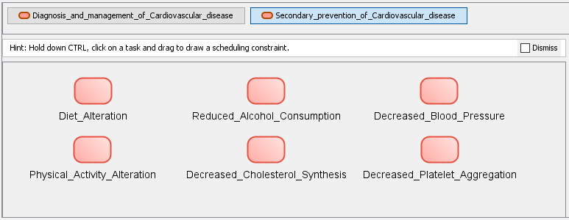







Addresses metaproperty: Verb: prevent, Noun phrase object: Cardiovascular diseases N0000000689 NDF-RT

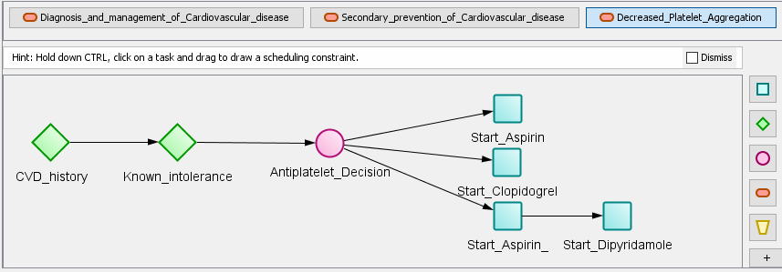









Addresses metaproperty: Verb: achieve, Noun phrase object: Decreased Platelet Aggregation, N0000008832 



NDF-RT

Addresses metaproperty: Verb: start, Noun phrase object: Aspirin, N0000145918 NDF-RT

Arguments (for: +; against: -)

1 – (cardiovascular_disease = YES or transient_ischemic_attack =YES) and sinus_rhythm = NO; +

Aspirin_contrainditcation = YES or Aspirin_unnacceptable_sideffects = YES; -

2– (cardiovascular_disease = YES or transient_ischemic_attack =YES) and sinus_rhythm = NO; +

Aspirin_contrainditcation = YES or Aspirin_unnacceptable_sideffects = YES; +

3– (cardiovascular_disease = YES or transient_ischemic_attack =YES) and sinus_rhythm = YES; +

sinus_rhythm = NO or (Aspirin_contrainditcation = YES or Aspirin_unnacceptable_sideffects = YES); -

Figure 1-1. CVD CIG hierarchy trees (a) secondary prevention of CVD plan and its goal metaproperties and (b) Decreased Platelet Aggregation plan and its Addresses metaproperty. The tasks that make up this plan include two enquiries that collect patient information, followed by a decision between three different antiplatelet medications. (c) shows the Addresses metaproperty information for the action-enactment goal “Start Aspirin”. (d) shows the PROforma arguments for the Antiplatelet Decision that determines which action-enactment goal will be selected. The Addresses metaproperty is visualized concisely but in the PROforma CIG they are specified in JSON syntax as in examples below.



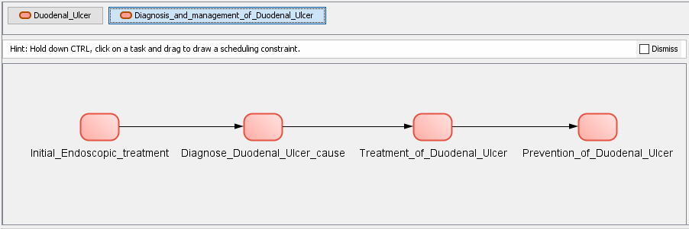



Addresses metaproperty: Verb: manage, Noun phrase object: Duodenal ulcer, N0000001008 NDF-RT

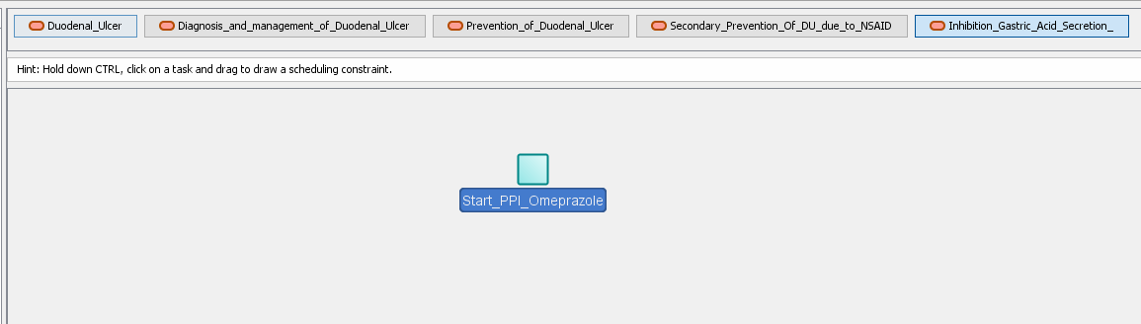



Addresses metaproperty: Verb: achieve, Noun phrase object:

Type: PE, Modifier: Inhibition, Clinical attribute: Gastric Acid Secretion

Name: Inhibition Gastric Acid Secretion, Code: N0000009724, Vocabulary: NDF-RT



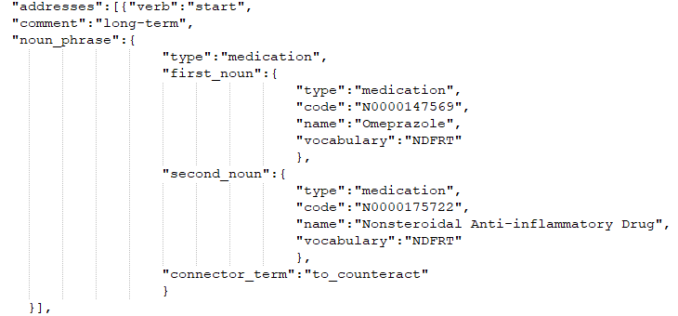

Figure 1-2. DU CIG for (a) Diagnosis and management of Duodenal Ulcer with its inner plans and its Addresses metaproperty, (b) Inhibition Gastric Acid Secretion (child of secondary prevention of DU due-to NSAID) and its Addresses metaproperty. The Addresses metaproperty is visualized concisely in parts a, b, but in the PROforma CIG they are specified in JSON syntax as in (c) the Addresses metaproperty of the action-enactment goal of Start PPI. The Addresses metaproperty has a verb - “start”, and a complex noun phrase object where the first noun phrase is Omeprazole, that was started (with the connector term) “to counteract”, NSAID.

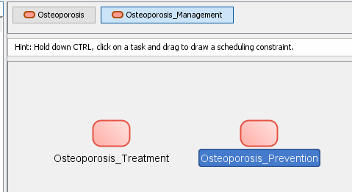

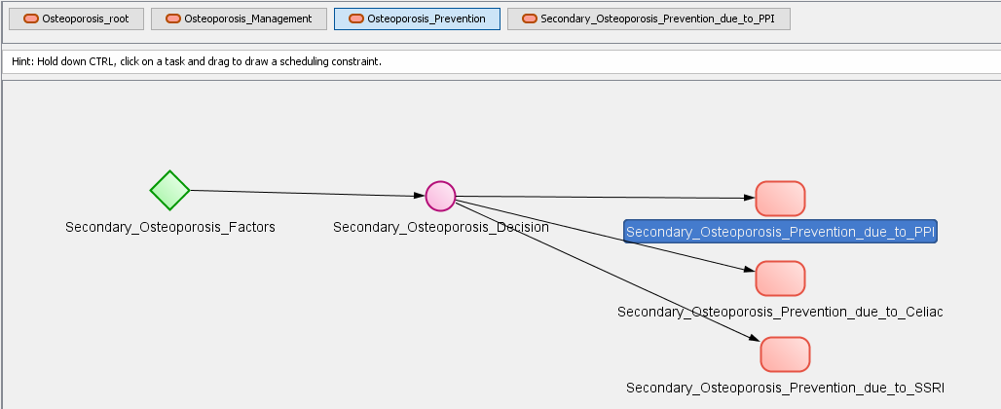

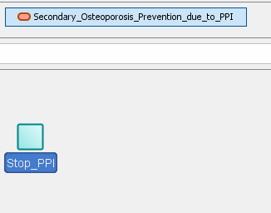

Figure 1-3. Osteoporosis CIG PROforma modeling hierarchy.

The Goal Trees for this case are shown in Figure 3.

* Show the encoded patient data

All data is modeled according to standard data models, ontologies and terminologies. The patient data is modeled according to the HL7 FHIR standard, SNOMED-CT and National Drug-File Reference Terminology (NDF-RT) provided by the U.S. Department of VA.

* The patient data is located in a fhirbase database – a database implementation provided by FHIR, implemented using PostgreSQL. The database contains tables that instantiate all FHIR resources and contain the patient’s information in a json formatted object.
* The following FHIR resources are used:
* Patient’s demographics
* Medications
* Observations
* Encounters
* Procedures
* Goals
* Conditions:
* Example of a FHIR resource (for Case 1): Duodenal Ulcer (DU)

{

"resourceType": "**Condition**",

"id": "1725477",

"clinicalStatus": {

"coding": [ {

"system": "http://terminology.hl7.org/CodeSystem/condition-clinical",

"code": "active"

} ] },

"verificationStatus": {

"coding": [ {

"system": "http://terminology.hl7.org/CodeSystem/condition-ver-status",

"code": "confirmed"

} ]

},

"category": [ {

"coding": [ {

"system": "http://snomed.info/sct",

"code": "282291009",

"display": "Diagnosis of"

} ]

} ],

"code": {

"coding": [ {

"system": "http://hl7.org/fhir/ndfrt",

"code": "N0000001008",

"display": "**Duodenal ulcer**"

} ]

},

"subject": {

"reference": "Patient/130",

"display": "Linda Williams"

},

"onsetDateTime": "2015-05-11",}

Figure 1-4 FHIR Observation of DU (that the patient exhibits)

* If applicable, show how adverse interactions (features A1-A7) were encoded a-priori

Not applicable

* If applicable, show/reference the encoding of additional domain knowledge
  + Aspirin has the physiological effect of “Decreased Platelet Aggregation”, N0000008832.
  + Omeprazole has the physiological effects of “Inhibition Gastric Acid Secretion, N0000009724.
  + The subsumption hierarchy of the NDF-RT allows us to determine that “Nonsteroidal Anti-inflammatory Drug Subsumes Aspirin”. This allows the algorithm to detect the interaction between “stop NSAID” (DU guideline) and “start Aspirin” recommended (CVD guideline).
  + Similarly, from NDF-RT: “Proton Pump Inhibitor Subsumes Omeprazole”. This allows the algorithm to detect the interaction between “stop PPI” (Osteoporosis guideline) and “start PPI” (DU guideline).
  + The fact that PPI is a risk contributing factor to Osteoporosis was not explicitly stated in the guideline. It was concluded with the help of our expert physician, based on Table 11 of the Osteoporosis guideline where PPIs are listed and it is stated that “Consider alternative therapy or reassessment for causes of secondary osteoporosis in patients who have recurrent fractures or significant bone loss while on therapy”.
  + The fact that a drug that causes a side effect should be stopped is general medical knowledge, which we represent explicitly in the Osteoporosis CIG.

### Processing (1 page):

* If applicable, explain how relevant interactions were (automatically) identified (features A1-A7)

**A1 Drug causes ADE** When GoCom recognizes an inconsistency, and the inconsistency stems from a recommendation in one of the guidelines to stop a drug, the system concludes that the drug is a source of a potential or existing ADE. (e.g., Osteoporosis due-to PPI and DU due-to aspirin are represented in the goal trees – see Figure 6: 2.4.1 and 3.2.1, in step 2 in Kogan et al. [1] Figure 8 (High-level Pattern) and steps 17, 18 in Kogan et al. [1] Figure 9 (Pattern B)).

**A2 Two or more drugs from different CPGs may interact** – While we don't support it directly, sometimes these interactions may be detected in our Goal Trees, when the drug-drug interactions can be encoded as inconsistent Physiological-Effect Goals. They will be detected as Goal Interactions. For example, the drug TMP has_PE increased coagulation; Warfarin has_PE decreased coagulation (Case 3). GoCom’s inconsistency checking (steps 17, 18 in Kogan et al. [1] Figure 9 (Pattern B)) would detect inconsistent increase vs. decrease goal verbs and the same coagulation noun phrase).

**A4 Conflicting actions (e.g., drugs, procedures) from different CPGs**. The inconsistency in [Osteoporosis. Stop PPI] vs. [DU, Start Omeprazole] is detected in steps 17, 18 in Kogan et al. [1] Figure 9 (Pattern B)) when we have start vs. stop and the noun phrases are either the same or one is a drug-group and the other is a specific drug belonging to the drug group (is-a hierarchy).

**A7 multiple interactions:**

We have interactions between the Osteoporosis CIG and the DU CIG and another interaction between the DU CIG and the CVD CIG. To resolve the first interaction, we need to revisit the second interaction (which occurred earlier in the patient's timeline).

The first interaction is between [Osteoporosis, Stop PPI] vs. [DU, Start Omeprazole] It is detected in steps 17,18 in Kogan et al. [1] Figure 9 (Pattern B) when we have inconsistent goals where the verbs are start vs. stop and the noun phrases are either the same or one is a drug-group and the other is a specific drug belonging to the drug group (is-a hierarchy).

For Start Drug tasks, we observe if the Drug has a to-counteract relation to another Drug (e.g., Start Omeprazole to-counteract Aspirin (step 25 in Kogan et al. [1] Figure 10 (Pattern D)). If we find one, we rerun the decision that recommended the other Drug (Aspirin) and see if other options are recommended (e.g., Clopidogrel). Then this Drug can replace Aspirin and thus Omeprazole to-counteract Aspirin does not need to be given. Therefore, in effect PPI is stopped and Aspirin is replaced by Clopidogrel.

* Explain how relevant interactions were (automatically) mitigated (features B1-B8)

**B1 Adding a drug to mitigate an adverse effect** - Add PPI to avoid DU: When the patient developed DU due to NSAID, Omeprazole (PPI) was added to mitigate this adverse effect, according to the DU guideline recommendation (step 2 in Kogan et al. [1] Figure 8 (High-level Pattern, where GoCom respond to a new problem by running a CIG for managing the problem)).

**B4 Replacing a drug with a safer / non-interacting drug / more effective drug for comorbidity**

The Controller detects the interaction [Osteoporosis, Stop PPI] vs. [DU, Start Omeprazole] and during mitigation detects the relationship “to_counteract” between [DU, Start Omeprazole] and [CVD, Start Aspirin] (As described for feature A7). The Controller mitigates the latter by looking for alternatives to [DU, Start Omeprazole] and [CVD, Start Aspirin] by rerunning the DU and CVD guidelines. In the CVD guideline, the Controller finds an alternative to Aspirin: Clopidogrel, and proposes to replace Aspirin with Clopidogrel in one of the options since it is safer for the patient at this point, as it has no indications of unacceptable side effects (unlike Aspirin) (steps 19,20 in Kogan et al. [1] Figure 10 (Pattern D), where an alternative sibling goal is added).

**B5 Discard unsafe/interacting drug –** During mitigation of the interaction [Osteoporosis, Stop] PPI vs. [DU, Start Omeprazole], the Controller proposes to discard Omeprazole in one of the options (after no alternative has been found in the guideline) as the interaction indicates that Omeprazole is an unsafe drug (steps 14,15 in Kogan et al. [1] Figure 10 (Pattern D)).

Mor's alternative text: ADE is detected and action of start omeprazole is stopped (cancel unsafe/interaction option). The goal of prevent/treat DU is not met and preplanning is invoked but the only option in the CIG is the PPI (no other optional drug). In this case, the Controller also proposes the compromised solution of having an unmet goal (cancel goal): not meeting treat DU and keeping the Aspirin without PPI (steps 14,15 in Kogan et al. [1] Figure 10 (Pattern D)). Note that the option of replacing aspirin with Clopidogrel is also proposed - see B4)

**B8: Other mitigation strategies for the multimorbidity CPG problem that you have implemented** -

* If applicable, explain how other relevant features were realized (features C1-C4)

**C1 Patient preferences and/or patient burden –** The Controller produces multiple option-sets with different alternative recommendations for each goal of the patient. In case 1, the Controller proposes in option 1 to keep the goals [CVD, Start Aspirin] and [DU, Start Omeprazole], and reject the goal [Osteoporosis, Stop PPI]. In option 2, to keep the goal [CVD, Start Aspirin], Cancel the goal [DU, Start Omeprazole] and complete the goal [Osteoporosis, Stop PPI]. In option 3, to replace Aspirin with Clopidogrel, to complete the goal [DU, Start Omeprazole] and to complete the goal [Osteoporosis, Stop PPI]. The ability to present a range of solutions that the patient and physician can choose from allows to consider the patient’s preferences more so than if there was only one solution produced (step 12 in Kogan et al. [1] Figure 8 (High-level Pattern)). For instance, the first option-set in Case 1, proposes to reject the recommendation from the Osteoporosis guideline to “Stop Omeprazole”. This is also a clinically valid option and it would keep the patient on their current medications that work well for them (if they so choose), as some patients do not like change.

**C3 Explanation of the mitigation strategy(ies) –** After the different options are created, the Controller creates explanations for each individual goal in each option and a higher-level explanation for each option. The explanations for the individual goals are either retrieved from the guideline or can be auto-generated by the Controller according to pre-defined patterns that take into account the verb and lifecycle Status attribute of the goal (steps 15-27 in Kogan et al. [1] Figure 12 (Pattern F) and in Kogan et al. [1] Table 2). The explanation for completing the goal [DU, Start Omeprazole] is “if Aspirin is not needed, no option is recommended by the new DU guideline and the goal Secondary Prevention of Duodenal Ulcer due to NSAID-Inhibition Gastric Acid Secretion is completed”. Explanations for option-sets are generated automatically and are constructed by counting the goals that are met and unmet according to their lifecycle Status attribute and proposed action (steps 7-10 in Kogan et al. [1] Figure 12 (Pattern F)). In addition, the high-level explanation displays the action goals that are in the option-set (steps 12-13 in Kogan et al. [1] Figure 12 (Pattern F)). The explanation for option-set 3 is: “All goals are met. The actions are: Replace: Aspirin with Clopidogrel and stop Omeprazole.”.

**C4 Alternative mitigation strategies for a single interaction –** The Controller produces multiple option-sets by applying different mitigation strategies to an interaction. When mitigating the interaction [Osteoporosis, Stop PPI] vs. [DU, Start Omeprazole], the Controller tries to find alternative recommendations by rerunning the Osteoporosis and DU guidelines and then discards goals if no alternatives are found. An additional mitigation strategy is used when the Controller addresses the relationship “to_counteract” between [DU, Start Omeprazole] and [CVD, Start Aspirin] (Figure 10 (Pattern D)).

**C5: Explicit support for decision making among conflicting goals and actions** (i.e., considering priorities and tradeoffs)

For example, if the aspirin that is causing duodenal ulcer was given for primary prevention of CVD, it may be acceptable to stop aspirin, giving up the goal of primary prevention.

* Explain which parts of the processing are generic and which need to be hardwired for the case[2]

Processing is not hard-wired.

Replacement drugs are representing in the CIGs.

The DU guideline specifies adding PPI in order to meet the goal of Inhibition Gastric Acid Secretion, which is part of the Secondary Prevention of DU due-to NSAID subguideline.

The Osteoporosis CIG includes an action of Stop PPI – to meet the goal of secondary Osteoporosis due-to PPI.

### Output (1 page):

* Show and explain how the result of the processing is represented

The results of the processing have intermediate representation as alternative Goal trees (See Figure 1-5).

**Goal Forest**

**1.2 Cardiovascular disease Secondary prevention**

**1.2.6 Decreased Platelet Aggregation**

**1.2.6.1 Replace Aspirin with Clopidogrel**

**1.2.6.1 start Aspirin**

**2.4.1 Secondary prevention of Duodenal Ulcer due to NSAID**

**2.4.1.1 Inhibition Gastric Acid Secretion**

**2.4.1.1.1 start Omeprazole to_counteract Nonsteroidal Anti-inflammatory Drug**

**3.2 Osteoporosis prevention**

**3.2.1 Secondary Osteoporosis Prevention due to PPI**

**3.2.1.1 stop Omeprazole**

Figure 1-5. A schematic representation of the 3 goal trees for the 3 CIGs.

From these, the final output of the goals sets and explanations are derived and presented to users.

The method reports to the user all of the goals for the patient and non-conflicting option sets that meet the goals along with automatically-generated explanations generated from the CIG representation that includes quotes from the CPGs and automatically-generated explanations on the strategy of mitigation and how it has been applied for the case.

Each option-set includes a set of options from the different goal trees of the patient – the ones involved in mitigating the conflicting goals. An option-set is a subtree of the goal tree where the siblings, if any, represent a conjunction of sub-goals. In this example, there is no conjunctive sub-goals, therefore an option in the set corresponds to a path from the root of the tree to a single node. The nodes in the full goal tree, or in the option-pathway are represented as a Goal FHIR object, that starts in the root node, with children that are also Goal FHIR objects with children, all the way down to the leaf-node. Note that the property "Proposed action" – contains the future status of the goal as proposed by the Controller during mitigation. In case a goal is to be replaced, will also contain the replacement goal object of the current goal.

Figure 1-6 provides a schematic representation of Option-set with one pathway for each CIG. Each pathway has 3 nodes from root to leaf. Each line below corresponds to a node in the pathway. The indentation reflects a child-parent relationship.

**Option-set 3 Replace Aspirin with Clopidogrel and stop Omeprazole; proposed**

**1.2 Cardiovascular disease Secondary prevention**

**1.2.6 Decreased Platelet Aggregation**

**1.2.6.1 Replace Aspirin with Clopidogrel**

**1.2.6.1 (existing child)**

**Proposed_action: replace [action_object_1: 1.2.6.1 (start Aspirin)]**

**with**

**[action_object_2: 1.2.6.2 (start Clopidogrel)]**

**//explanation text taken from action_object_2**

**2.4.1 Secondary prevention of Duodenal Ulcer due to NSAID**

**2.4.1.1 Inhibition Gastric Acid Secretion**

**2.4.1.1.1 start Omeprazole to_counteract Nonsteroidal Anti-inflammatory Drug**

**Proposed_action: complete // complete the recommendation to start Omeprazole - auto-generated**

**3.2 Osteoporosis prevention**

**3.2.1 Secondary Osteoporosis Prevention due to PPI**

**3.2.1.1 stop Omeprazole**

**Proposed_action: complete //complete the recommendation to stop Omeprazole - auto-generated**

Figure 1-6. A schematic representation of the json for Option set 3.

Note that as compared to Figures 3 and 4, there is also a proposed_action part. The proposed action may be to accept, reject, keep, replace, suspend, activate, cancel and complete a goal/action.

After the user selects his preferred option set, the goal tree is updated as is the patient's EHR.

* Show and explain what user interactions were involved in the use case
  + User adding a new problem - Osteoporosis (which triggers the CDS)
  + System providing explanations to the user – See below.
  + User selecting one of the recommended option sets (Option 3 in Figure 1-7). This results in the patient’s EHR being updated

The method reports to the user all of the goals for the patient and non-conflicting option sets that meet the goals along with automatically-generated explanations generated from the CIG representation that includes quotes from the CPGs and automatically-generated explanations on the strategy of mitigation and how it has been applied for the case.

Each option-set includes a set of options from the different goal trees of the patient – the ones involved in mitigating the conflicting goals. An option-set is a subtree of the goal tree where the siblings, if any, represent a conjunction of sub-goals. In this example, there is no conjunctive sub-goals, therefore an option in the set corresponds to a path from the root of the tree to a single node. The nodes in the full goal tree, or in the option-pathway are represented as a Goal FHIR object, that starts in the root node, with children that are also Goal FHIR objects with children, all the way down to the leaf-node. Note that the property "Proposed action" – contains the future status of the goal as proposed by the Controller during mitigation. In case a goal is to be replaced, will also contain the replacement goal object of the current goal.

Figure 1-7 shows the 3 options sets for Case1. Figures 1-8 and 1-9 show explanations about one goal from one option set and about an entire Option Set, respectively.

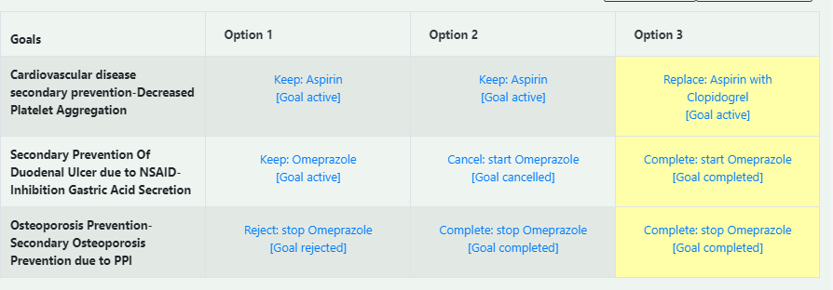

Figure 1-7. the 3 option sets for Case 1

There are individual explanations for each recommendation which the user can see when they click on the recommendation for one goal of one of the decision options:

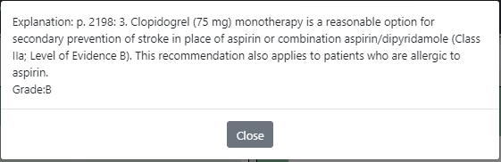

Figure 1-8. An explanation for the recommendation to replace Aspirin with Clopidogrel – retrieved from the guideline.

As well as explanations for the entire option set:

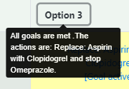

Figure 1-9. An explanation for the entire option-set. The explanation is auto-generated.

* Explain any additional considerations.

Not applicable

1. J. Fox, R. P. Cooper, and D. W. Glasspool, “A canonical theory of dynamic decision-making,” *Frontiers in Psychology*, vol. 4, no. APR, 2013.
2. There are two aspects: (**1**) processing algorithm: in a generic approach, only models change across case studies, while a hardwired approach requires tweaking the algorithm for each case study; (**2**) domain knowledge: a mitigation strategy can be generic or hardwired: e.g., deriving which drug should replace another drug can come from a knowledge base or be hard-wired for each case study (e.g., based on guidelines). There can be degrees of generality as well, of course.